Spring 2017 Exam 4A Chemistry 102 Name __

Multiple Choice (50 points)

Page 5 (31 points)

Page 6 (23 points)

Total (104 points)

Percent Grade ____________

**Useful Information**

|  |  |  |  |  |
| --- | --- | --- | --- | --- |
|  |  |  |  |  |
| Guanine | Adenine | Thymine | cytosine | Uracil |

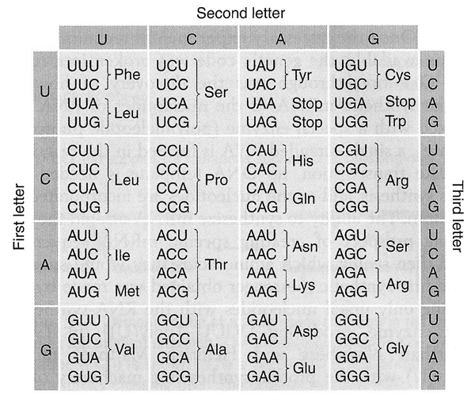

Multiple Choice

1. If a covalent bond forms between an enzyme and an inhibitor the reaction catalyzed by this enzyme will have undergone ________.

|  |  |  |
| --- | --- | --- |
| 1. Irreversible inhibition | 1. Competitive inhibition | 1. Feedback control |
| 1. Noncompetitive inhibition | 1. Genetic control |  |

1. You are studying the effects of temperature on the rate of a particular enzyme-catalyzed reaction. When you increase the temperature from 40°C to 70°C, what effect will this have on the rate of the reaction?

|  |  |
| --- | --- |
| 1. It will increase. | 1. It will decrease. |
| 1. It will decrease to zero because the enzyme denatures. | 1. It will increase and then decrease. |
| 1. This cannot be answered without more information. |  |

1. Which of the following amino acids is most likely to be found in the hydrophobic interior of a protein?

|  |  |  |  |  |
| --- | --- | --- | --- | --- |
| 1. Ser | 1. Phe | 1. Asn | 1. Gln | 1. Arg |

1. Which statement about amino acids is NOT correct?

|  |  |
| --- | --- |
| 1. Naturally occurring amino acids are ‘L’ amino acids | 1. Amino acids in proteins are known as α-amino acids |
| 1. There are 20 common amino acids found in proteins. | 1. All are correct statements concerning amino acids |

1. The peptide bond in proteins is chemically the same as a ___________bond.

|  |  |  |
| --- | --- | --- |
| 1. ether | 1. amide | 1. alkene bond |
| 1. disulfide | 1. ester |  |

1. The isolectric point of an amino acid is the pH

|  |  |
| --- | --- |
| 1. Equal to its pKa. | 1. At which it exists in acid form |
| 1. Which it exists in zwitterionic form. | 1. At which it exists in neutral form. |
| 1. At which it exists in basic form |  |

1. What type of bonding interaction occurs when two amino acid side chains, one containing a carboxyl group and the other an amino group, are in close proximity in the tertiary structure of a protein?

|  |  |  |
| --- | --- | --- |
| 1. a peptide bond | 1. an amide bond | 1. a disulfide bond |
| 1. a hydrophobic bond | 1. a salt bridge |  |

1. Which arrow below represents the reaction that would form the GA dinucleotide?



|  |  |  |
| --- | --- | --- |
| 1. **1** | 1. 2 | 1. 3 |
| 1. 4 | 1. 5 |  |

1. The tRNA anticodon:

|  |  |
| --- | --- |
| 1. inhibits encoding of protein at a specific codon | 1. inhibits tRNA function |
| 1. provides feedback inhibition in the synthesis of tRNA | 1. binds selectively to a 3 base sequence in mRNA |
| 1. none of the above |  |

1. Which of the following types of RNA is paired with a correct piece of information about that type of RNA?

|  |  |
| --- | --- |
| 1. tRNA; contains exons | 1. mRNA; contains codons |
| 1. rRNA; contains anticodons | 1. more than one correct response |
| 1. no correct response |  |

1. The sugar found in an RNA nucleotide is________.

|  |  |  |
| --- | --- | --- |
| 1. D-rhamnose | 1. D-ribose | 1. 2-deoxy-D-ribose |
| 1. D-raffinose | 1. all listed |  |

1. The regions of immature RNA which code the message for the protein synthesis is

|  |  |  |  |  |
| --- | --- | --- | --- | --- |
| 1. anti-codons | 1. introns | 1. replicons | 1. exons | 1. plasmids |

1. The sequence of a short DNA segment is ATGGCAATAC. What name do we give to the Adenine (A) end of the molecule?

|  |  |  |
| --- | --- | --- |
| 1. 5'-OH end | 1. 3'-OH end | 1. C-terminus |
| 1. N-terminus | 1. None listed |  |

1. The two strands forming the double helix of DNA:
   1. Have the same nucleotide composition, but run in opposite directions.
   2. Have complementary nucleotide compositions, running in the same direction.
   3. Are bound to one another by non-covalent hydrogen bonds.
   4. Are mirror images (enantiomers) of one another.
   5. Contain ribose, phosphate and either purines or pyrimidines.
2. The backbone of a nucleic acid molecule consists of
   1. Alternating nitrogen bases and phosphate groups linked by amide bonds and strengthened by hydrogen bonds.
   2. Alternating sugar and phosphate groups linked by phosphate ester bonds.
   3. Alternating sugar and nitrogen base groups linked by amide bonds.
   4. Complementary bases joined by hydrogen bonds.
   5. Sugar molecules bonded from the #3 carbon of one molecule to the #5 carbon of the other by glycosidic linkages.
3. Which of the following nucleic acid base-pairs form the strongest bonding interactions in DNA?

|  |  |  |
| --- | --- | --- |
| 1. A-G | 1. T-C | 1. A-U |
| 1. G-C | 1. A-T |  |

1. Which statement concerning coenzymes and redox reactions is incorrect? Explain.
   1. Oxidation can be considered as loss of hydrogen or gain of oxygen.
   2. Reduction can be considered as gain of hydrogen or loss of oxygen.
   3. NAD is the oxidized form of NADH.
   4. An oxidation reaction cannot occur unless a reduction reaction also occurs.
   5. FAD is the reduced form of FADH2.
2. In metabolism, CoA-SH usually reacts directly with

|  |  |  |  |  |
| --- | --- | --- | --- | --- |
| 1. ketones | 1. esters | 1. carboxylic acids | 1. alcohols | 1. water |

1. Which enzyme is involved in the conversion of phosphoenolpyruvate to pyruvate?

|  |  |  |
| --- | --- | --- |
| 1. enolase | 1. ketolase | 1. pyruvate kinase |
| 1. pyruvate oxidase | 1. None listed |  |

1. Which of the following statements correctly describe(s) catabolic pathways?

|  |  |
| --- | --- |
| a. | They release energy as they degrade polymers to monomers. |
| b. | They consume energy to build up polymers from monomers. |
| c. | They do not depend on enzymes. |
| d. | They lead to the synthesis of catabolic compounds. |
| e. | both A and B |

1. Which of the following correctly describes citrate and isocitrate?

|  |  |
| --- | --- |
| a. | they are both secondary alcohols |
| b. | they are both tertiary alcohols |
| c. | citrate is a secondary alcohol, but isocitrate is a tertiary alcohol |
| d. | citrate is a tertiary alcohol, but isocitrate is a secondary alcohol |

1. The steps of glycolysis between glyceraldehyde 3-phosphate and 3 phosphoglycerate involve all of the following except:

|  |  |  |
| --- | --- | --- |
| 1. ATP synthesis | 1. Catalysis by phosphoglycerate kinase | 1. Oxidation of NADH to NAD+ |
| 1. Utilization of Pi. | 1. The formation of 1,3-bisphosphoglycerate | |

1. Which of the enzymes or reactions listed below is MOST important in the reoxidation of NADH under anaerobic conditions?
   1. Malate dehydrogenase
   2. Lactate dehydrogenase
   3. Conversion of glucose-6-phosphate 🡪 fructose-6-phosphate
   4. The conversion of isocitrate 🡪 α-ketoglutarate
   5. The conversion of oxaloacetate 🡪 malate
2. How many ATP molecules result from the “processing” of one acetyl CoA molecule through the common metabolic pathway?

|  |  |  |  |  |
| --- | --- | --- | --- | --- |
| 1. 24 | 1. 12 | 1. 8 | 1. 2 | 1. 36 |

1. Carbon dioxide (CO2) is released during which of the following stages of cellular respiration?
2. glycolysis and the oxidation of pyruvate to acetyl CoA
3. fermentation and glycolysis
4. the citric acid cycle and oxidative phosphorylation
5. oxidative phosphorylation and fermentation
6. oxidation of pyruvate to acetyl CoA and the citric acid cycle

Short answer

1. (14 points) Some questions have more than one answer, so mark all that apply.

|  |  |  |
| --- | --- | --- |
| 1. primary structure | 1. secondary structure | 1. tertiary structure |
| 1. quaternary structure | 1. All of them. |  |

1. The interaction between the side chains of the amino acids in a protein or between proteins is found in this(these) structure(s). ________
2. Peptide bonds join the amino acids in the peptide chain. ___________
3. Two polypeptide chains are held together with hydrogen bonds. ___________
4. Hydrogen bonding between along the protein “backbone” that gives a coiled shape to the protein. ___________
5. What level of protein structure is changed by an egg boiled in water for 10 minutes? ___________
6. What level of protein structure is changed when acid is added to milk to make yogurt? ___________
7. What level of protein structure is changed when hydrolysis of a protein occurs? ___________
8. (8 points) Consider the following segment of mRNA:

AUG UGG AAC UGA

1. What is the sequence of DNA that this strand of mRNA was transcribed from?

**___________________________________________**

1. What will be the amino acid sequence? A mutation occurs that results in the replacement of the ninth nucleotide in the mRNA with U. What will be the result in the protein?

Amino acid sequence **___________________________________________**

Effect of mutation:

Type of mutation:____________________________

1. (9 points) Where in the body does digestion of each take place and what enzyme(s) assist?

|  |  |  |  |
| --- | --- | --- | --- |
|  | 1. polysaccharides | 1. triglycerides | 1. proteins |
| Location |  |  |  |
| Enzyme(s) |  |  |  |

1. (9 points) Explain the difference between the 3 sites on the ribosome (E, P, and A)?

(P) site –

(A) site –

(E) site –

1. (8 points) Consider the two reactions below. Which one is exothermic?

|  |  |
| --- | --- |
|  | Reaction |
| A. | AcetylCoA + Oxaloacetate → citrate + CoASH + 8.0 kcal |
| B. | 7.5 kcal + Acetate + CoASH → AcetylCoA + H2O |

1. Suppose the above two reactions were coupled. What does coupled mean?
2. What is the net result of these two reactions being coupled?

____________________________________________________________________________

1. Would the overall coupled reaction be endothermic or exothermic? How much energy was absorbed or released?



1. (6 points) Given the following dipeptide
2. Label the C and N terminus on the structure
3. Complete the alkaline hydrolysis reaction of the following dipeptide by drawing the structures of the products as they would occur at high pH

**Citric Acid Cycle**

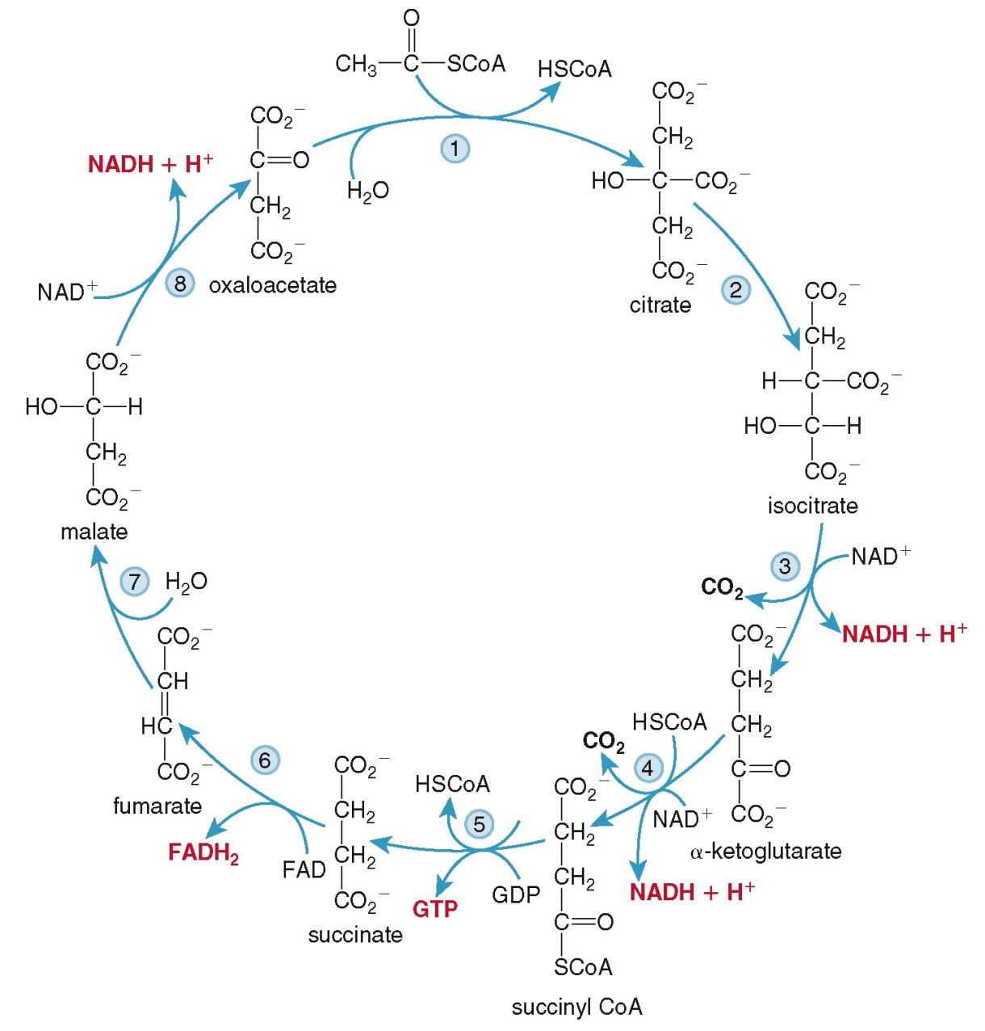

**Glycolysis**



